HW 9

DWBI

Shivam Verma

Screenshot of Talend data Profiling 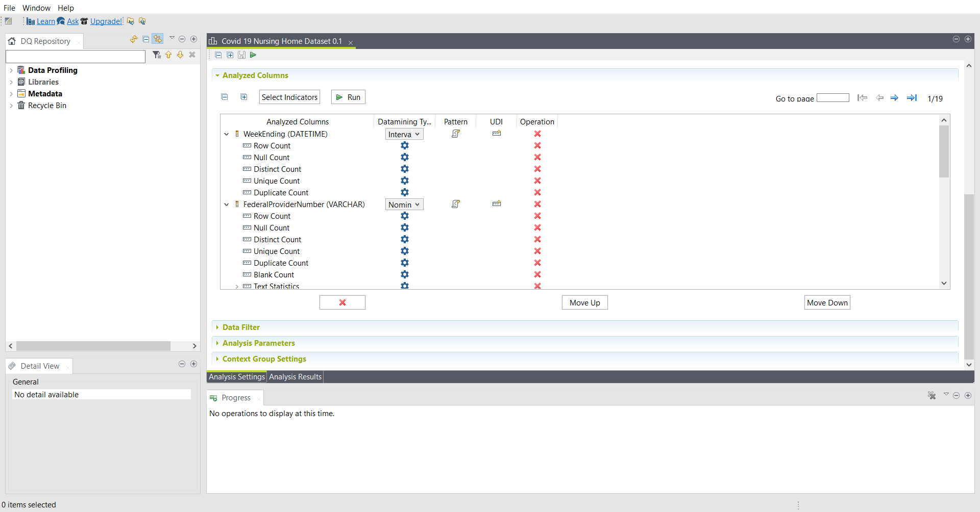

Talend Data Analysis results

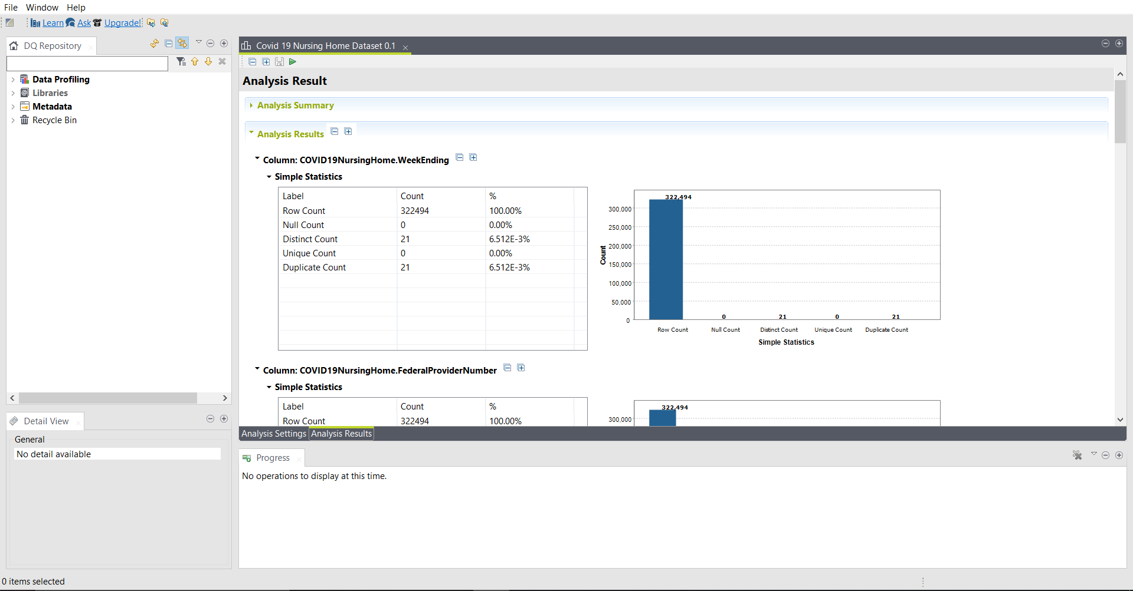

Screenshot of Package executed successfully:

Screenshot of data populated into table using SSIS:

Analysis of Data

